Simple html and Reveal JS example

Textual content
- This is the content of the first subsection
- The idea is to generate a website in the form of an html and the corresponding set of slides.
- The following content is only visible in the html website.
- The following content is only visible in the slides.
- This text should be visible if the GitHub action has been configured correctly.

Python figure
import numpy as np
import matplotlib.pyplot as plt
r = np.arange(0, 2, 0.01)
theta = 2 * np.pi * r
fig, ax = plt.subplots(
subplot_kw = {'projection': 'polar'}
)
ax.plot(theta, r)
ax.set_rticks([0.5, 1, 1.5, 2])
ax.grid(True)
plt.show()
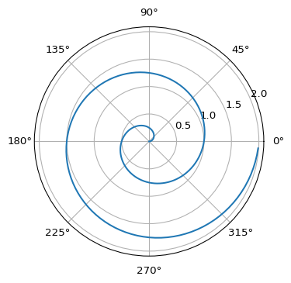
Figure 1: A line plot on a polar axis

